SHREYA PANCHAL
Assignment-7: Load Balancers Types of load balancer. Importance in high availability and fault tolerance. Set and configuration a load balancer in Aws.
1. In the AWS Management Console, launch two EC2 instances running a simple web server (use Amazon Linux 2 and install httpd or nginx), and verify both are accessible via their public IPs.
Answer:
- Launched two Amazon Linux 2 EC2 instances named WebServer-1 and WebServer-2.
- Installed and configured the Apache (httpd) web server on both instances.
- Created different web pages for each server.
- Verified that both websites were accessible using their public IPv4 addresses.
Result:
Both EC2 instances successfully hosted web pages and were accessible through their public IP addresses.
Configuration Steps:
- Open AWS EC2 Dashboard and click Launch Instance.
- Create WebServer-1 and WebServer-2 using Amazon Linux 2 (t3.micro).
- Enable Auto-assign Public IP.
- Configure the Security Group:
  - SSH (Port 22)
  - HTTP (Port 80)
- Launch both instances.
- Connect to each instance using EC2 Instance Connect.
- Install Apache Web Server:
- #sudo yum update -y
- #sudo yum install httpd -y
- #sudo systemctl enable httpd, #sudo systemctl start httpd
- Create a simple HTML webpage and restart Apache: #sudo systemctl restart httpd
- Open the Public IPv4 Address of both instances in a web browser to verify the websites.
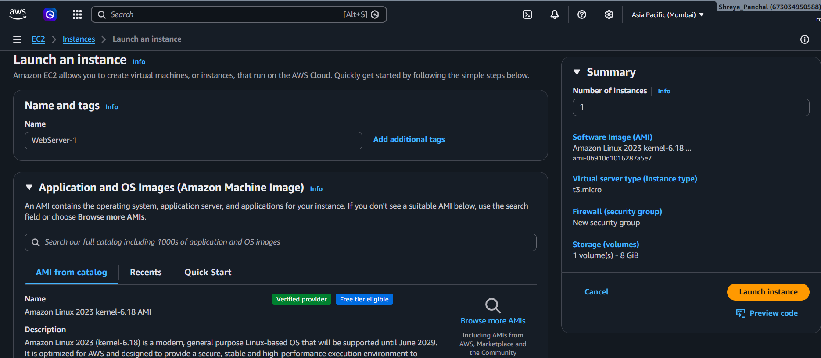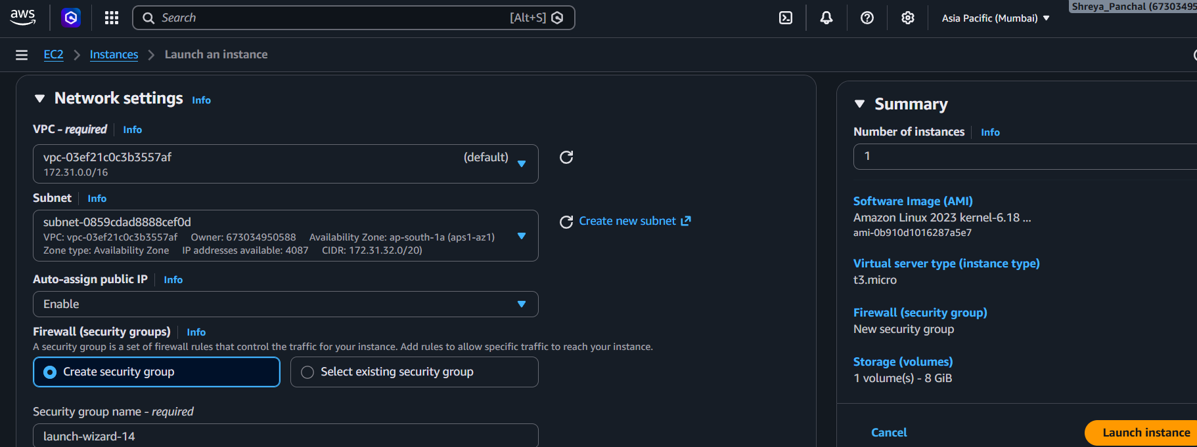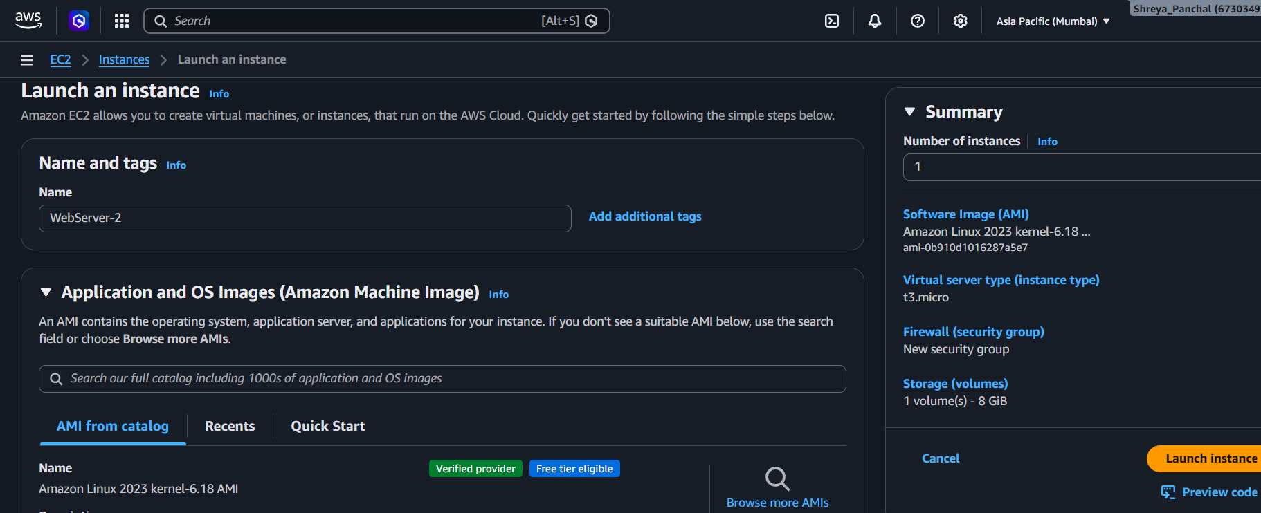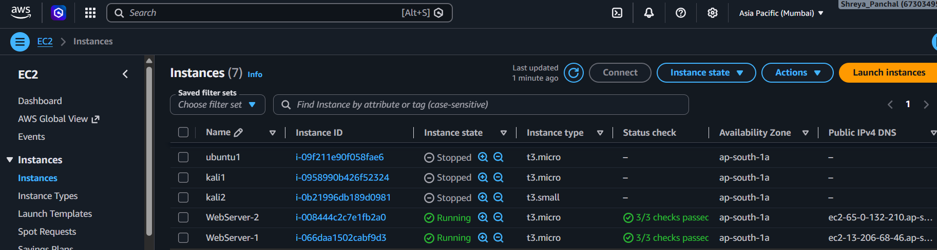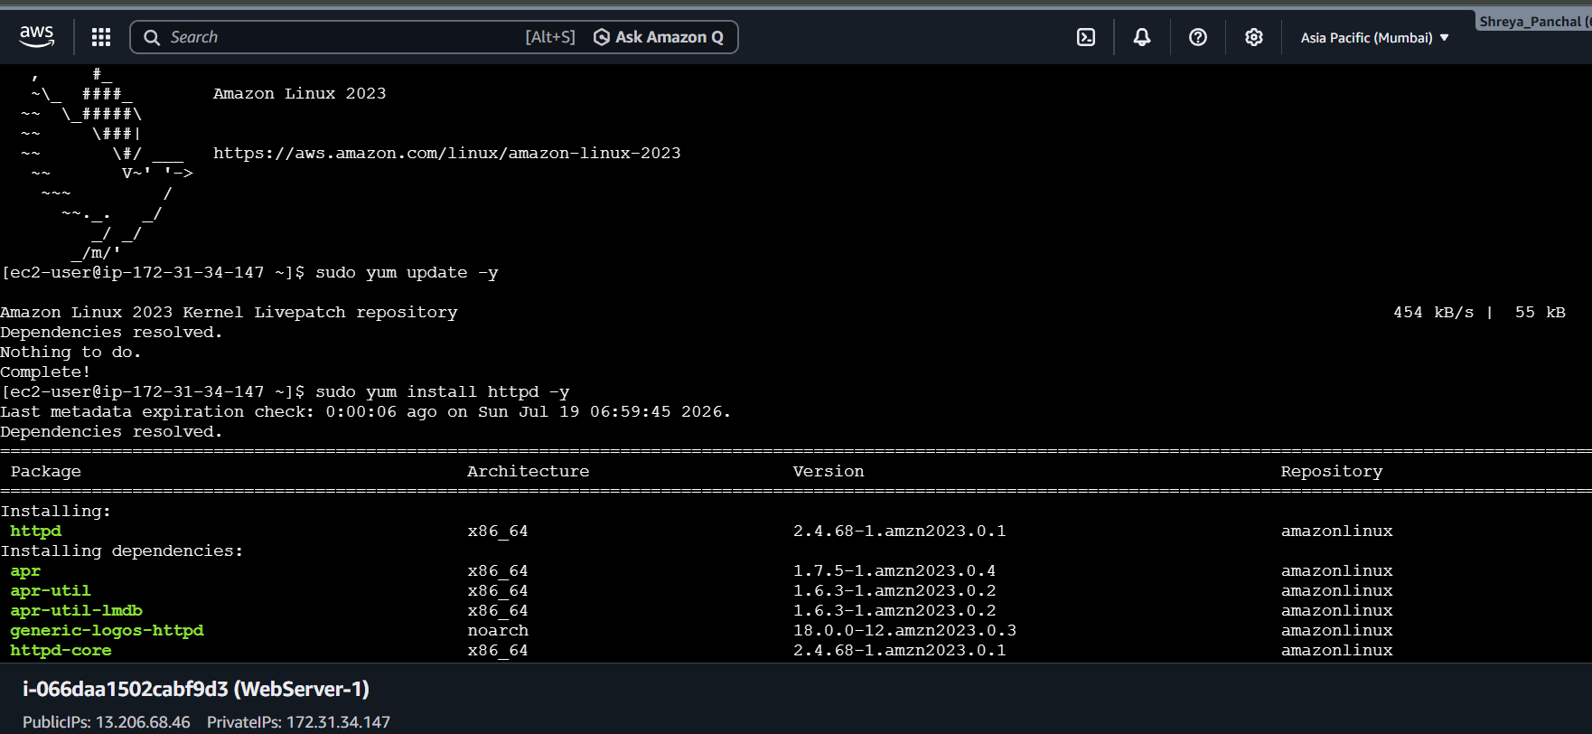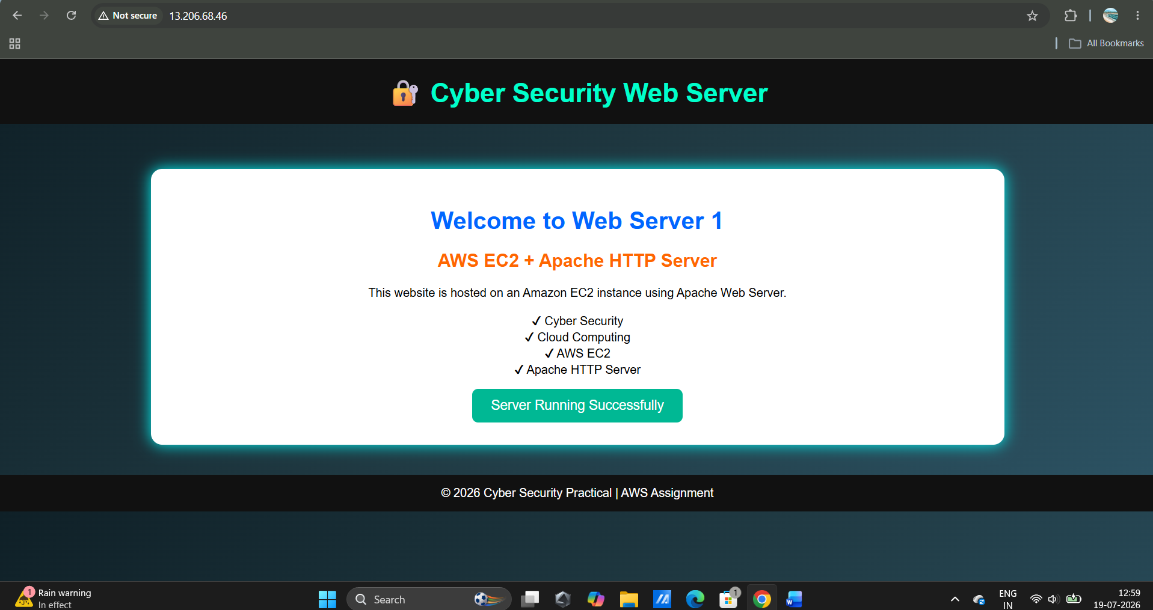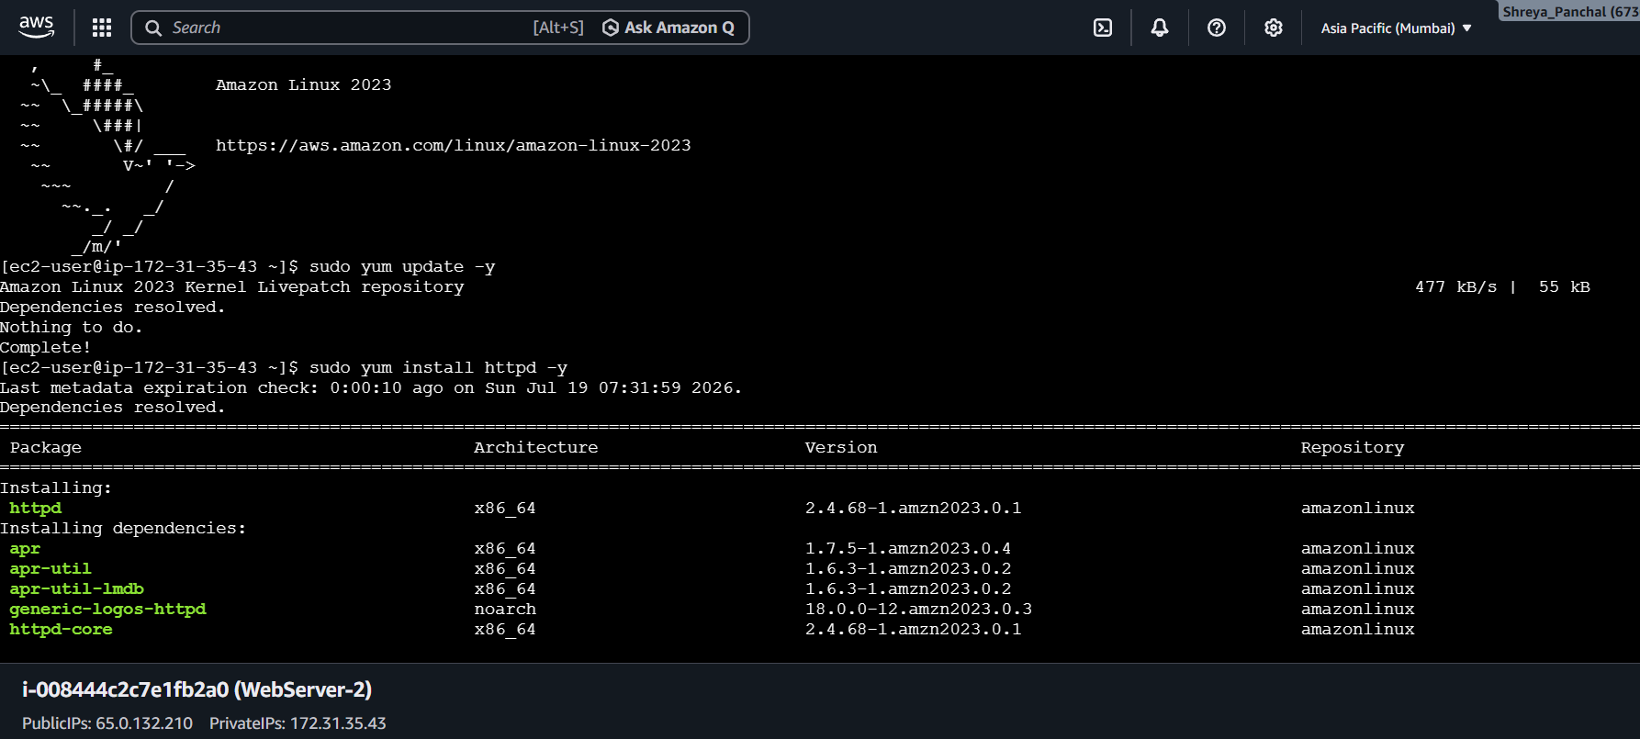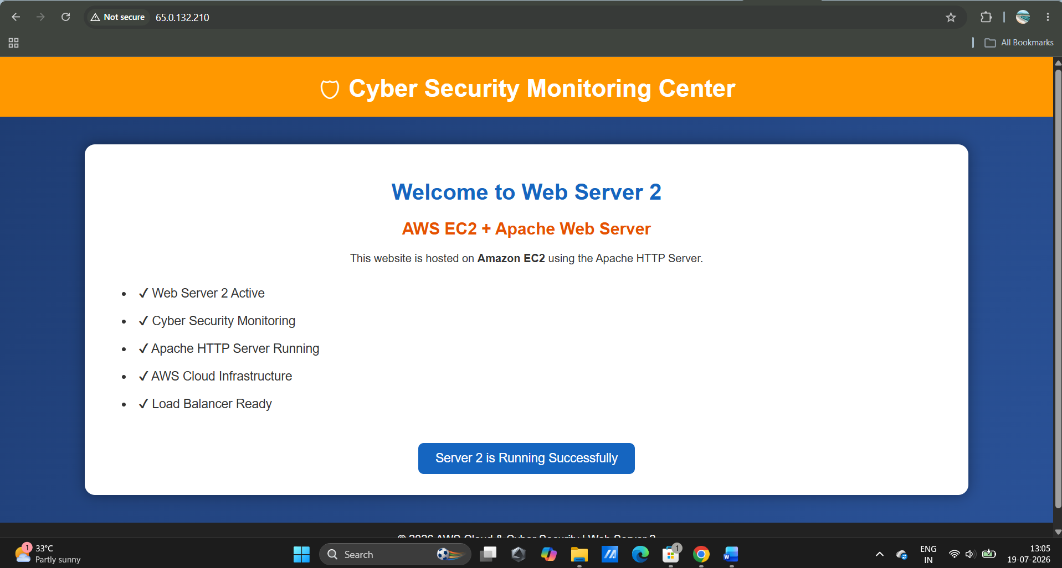

2. Set up an Application Load Balancer (ALB) in AWS that distributes incoming HTTP traffic across your two EC2 instances, and test by accessing the ALB's DNS name in your browser to see traffic served from both servers.
Answer: Configuration Steps
- Opened EC2 → Load Balancers and clicked Create Load Balancer.
- Selected Application Load Balancer (ALB).
- Configured the ALB as Internet-facing with IPv4.
- Selected the same VPC and two public subnets.
- Attached a Security Group allowing HTTP (Port 80).
- Created a Target Group and registered WebServer-1 and WebServer-2.
- Attached the Target Group to the ALB and created the Load Balancer.
- Waited until the ALB status became Active and both targets became Healthy.
- Opened the ALB DNS Name in a web browser and refreshed the page to verify that requests were served by both web servers.
Result
The Application Load Balancer successfully distributed incoming HTTP requests between WebServer-1 and WebServer-2, ensuring high availability and fault tolerance.
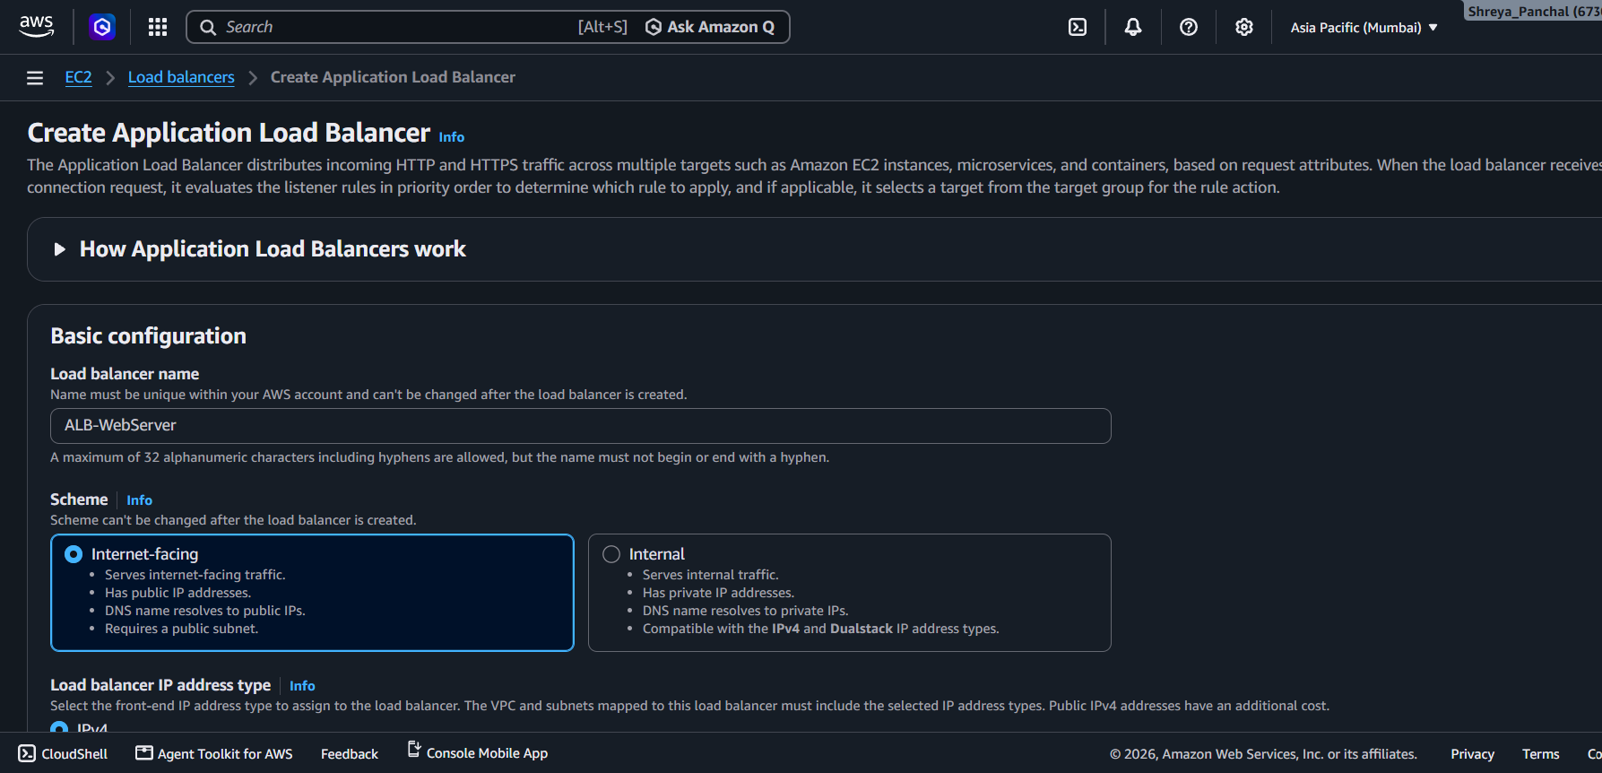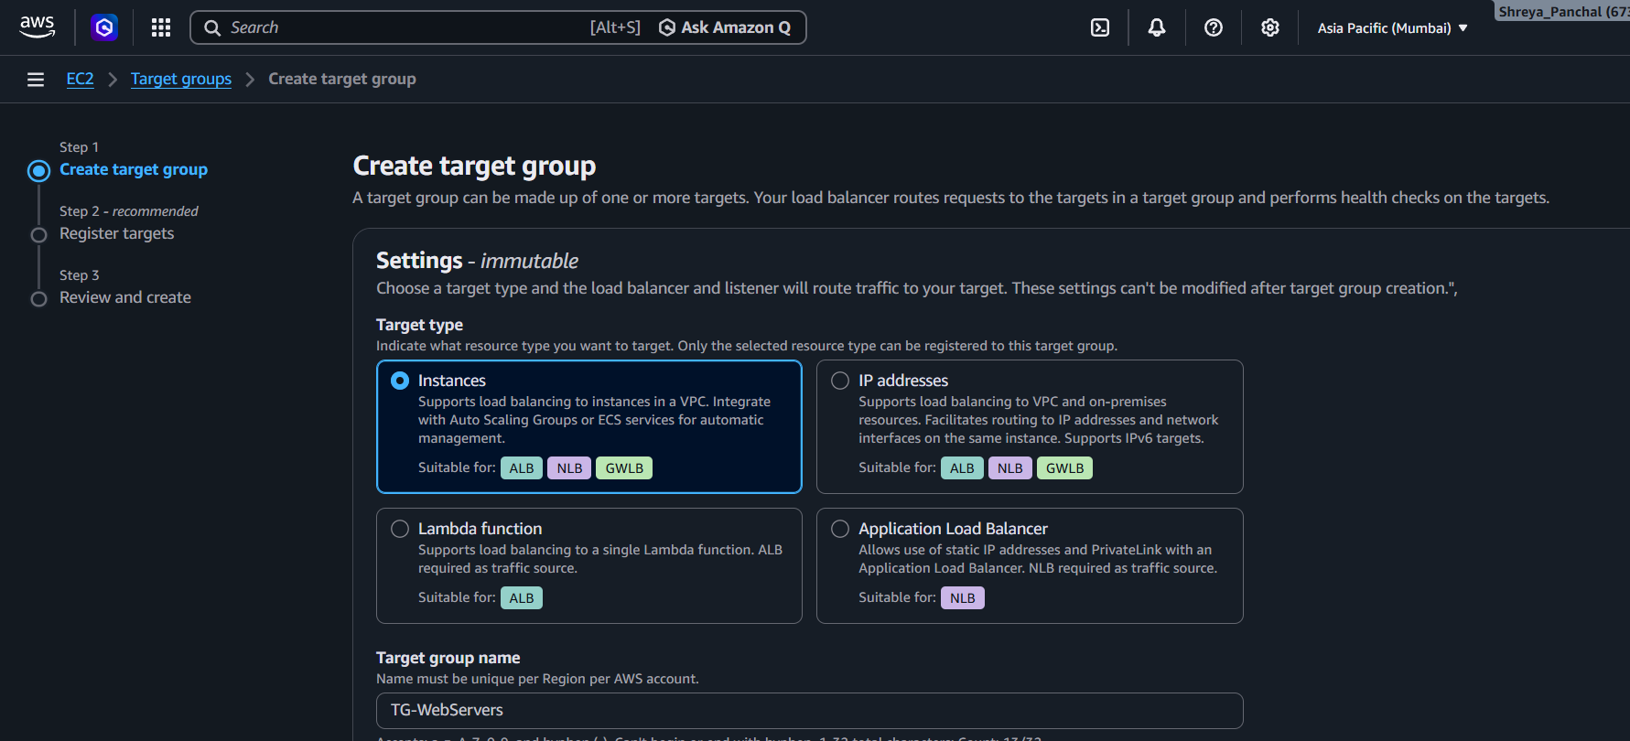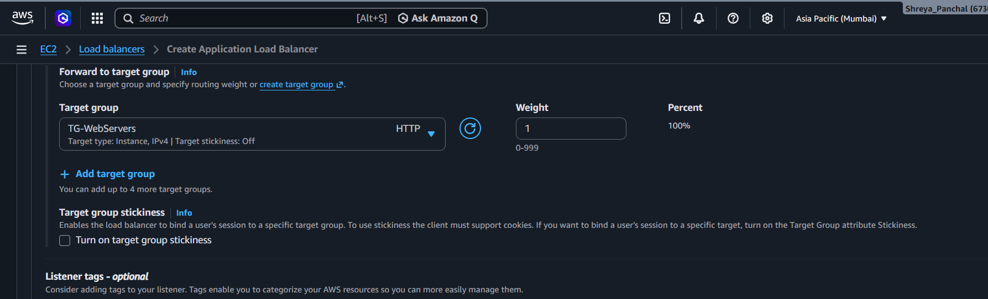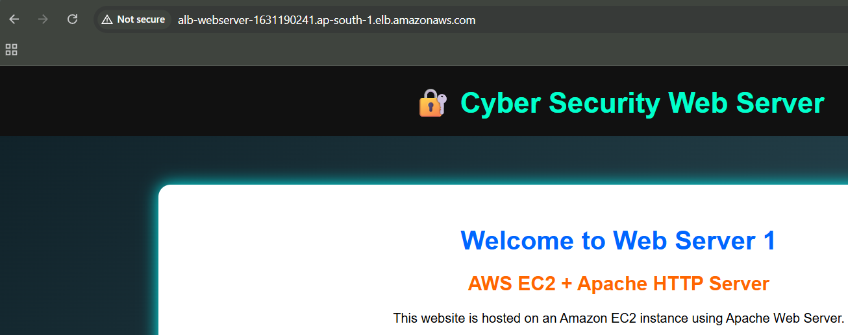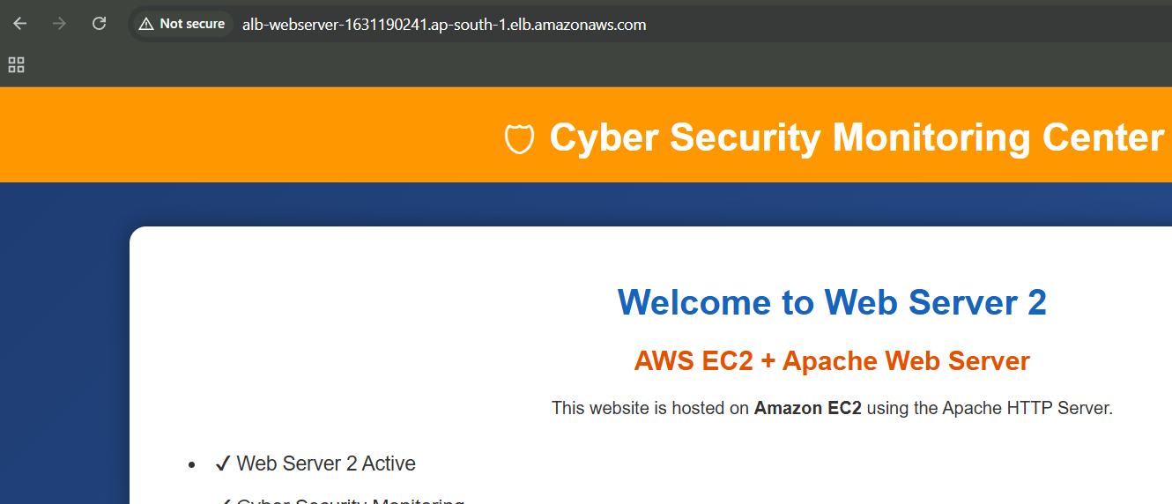

3. Change the health check settings of your ALB to use a custom path (e.g., /health) and verify that the load balancer only routes traffic to healthy instances.<br><br><em><strong>Hint:</strong> Create a /health endpoint on your web server that returns a 200 OK response.</em>
Answer: Configuration Steps:
- Created a custom /health endpoint on both EC2 instances.
- Verified that the endpoint returned 200 OK.
- Updated the Target Group Health Check path from / to /health.
- Waited for the health checks to complete.
- Verified that both EC2 instances became Healthy.
- Accessed the ALB DNS name and confirmed that traffic was routed only to healthy instances.
Result:
The Application Load Balancer successfully monitored the custom /health endpoint and routed traffic only to healthy EC2 instances.
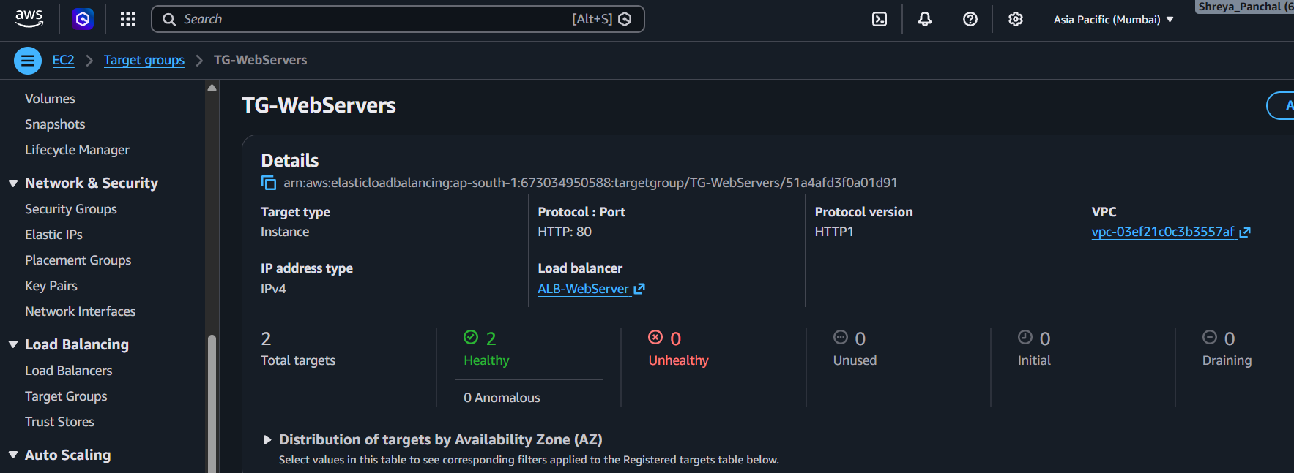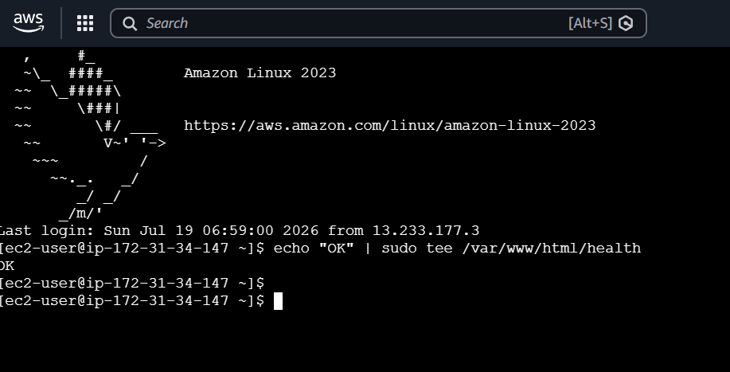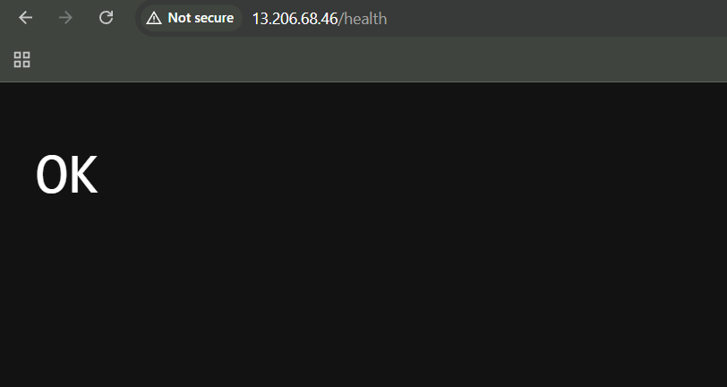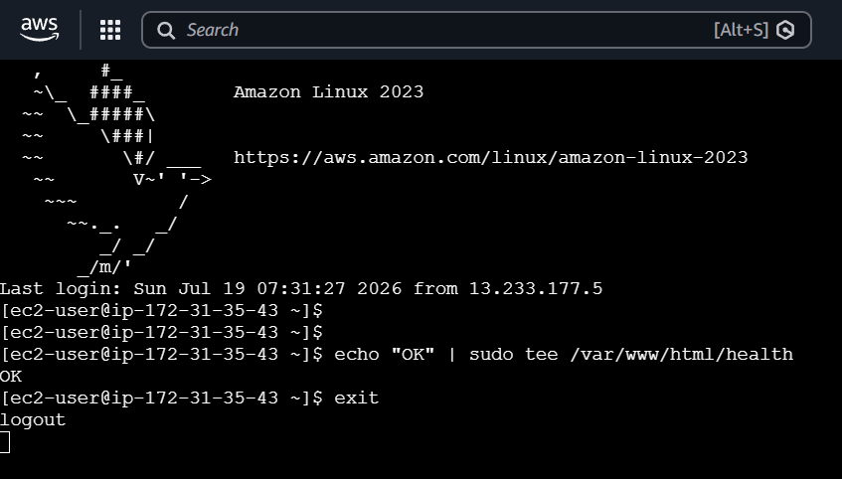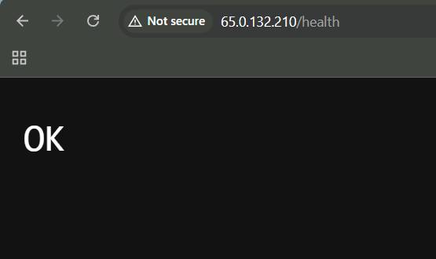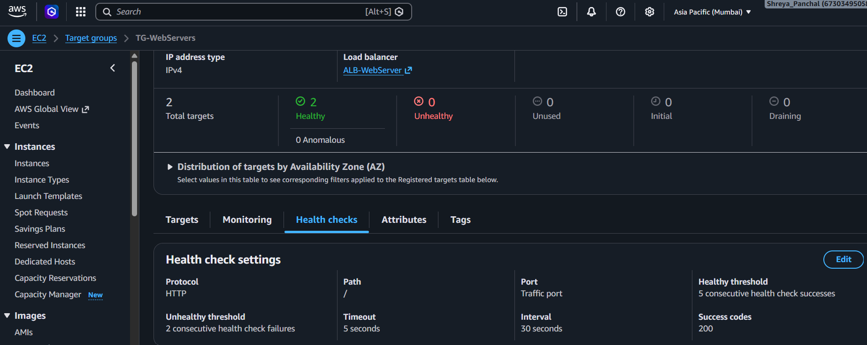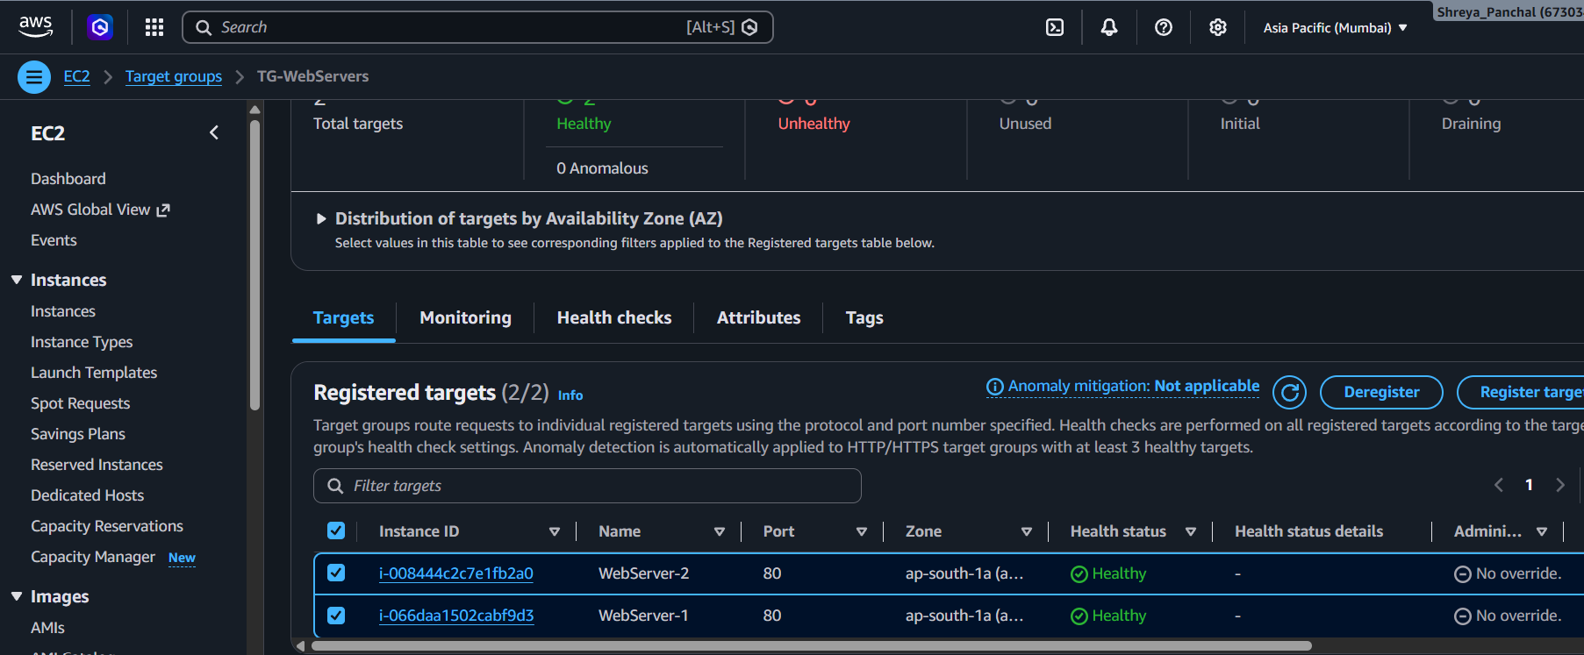
4.Simulate a server failure by stopping one of your EC2 instances and observe how the ALB handles requests — describe what happens and how this demonstrates high availability.
Answer: Simulate Server Failure
Configuration Steps:
- Stopped WebServer-2 from the EC2 console.
- Observed that the Target Group marked WebServer-2 as Unhealthy while WebServer-1 remained Healthy.
- Accessed the ALB DNS name and verified that all requests were routed only to WebServer-1.
- Started WebServer-2 again and confirmed that both instances returned to the Healthy state.
Result:
The Application Load Balancer automatically routed traffic only to the healthy EC2 instance when one server was unavailable. After the stopped instance was restarted and became healthy again, the ALB resumed distributing traffic between both instances. This demonstrates High Availability and Fault Tolerance.
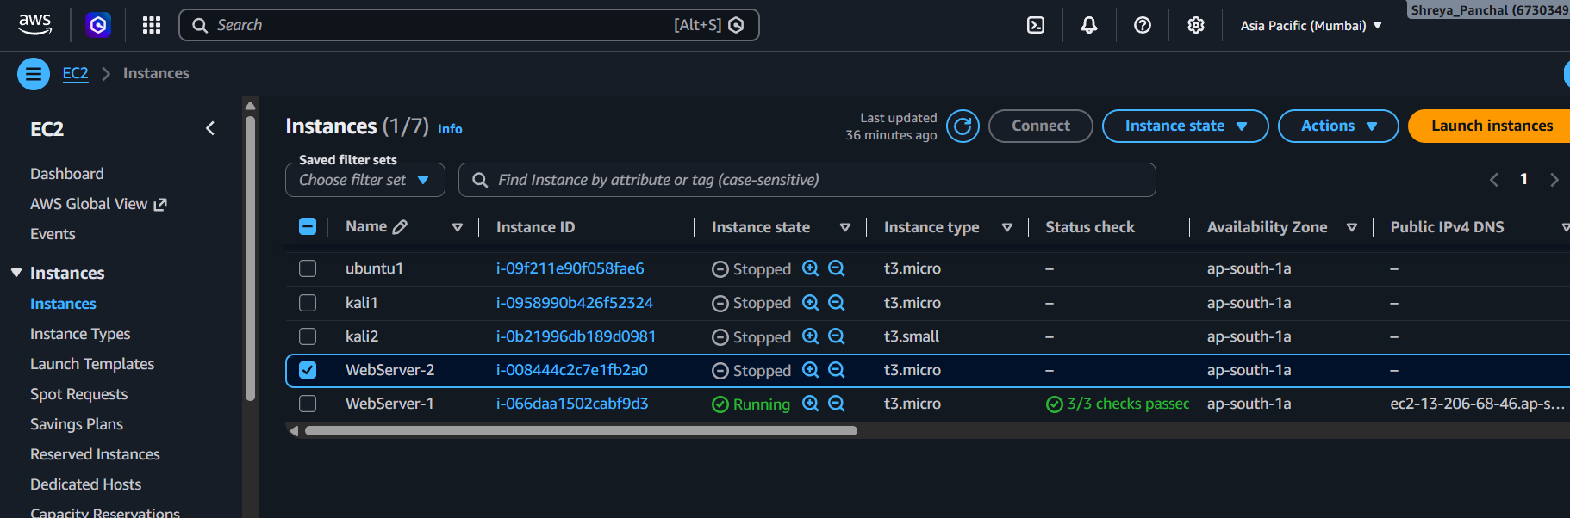
5.Compare Application Load Balancer, Network Load Balancer, and Classic Load Balancer in a table with at least 3 points each, focusing on supported protocols, use cases, and features.
Answer: Comparison of AWS Load Balancers:
Feature | Application Load Balancer (ALB) | Network Load Balancer (NLB) | Classic Load Balancer (CLB)
Supported Protocols | HTTP, HTTPS, WebSocket | TCP, UDP, TLS | HTTP, HTTPS, TCP, SSL
Use Case | Web applications, APIs, Microservices | High-performance applications, Gaming, VoIP | Legacy applications and simple load balancing
OSI Layer | Layer 7 (Application Layer) | Layer 4 (Transport Layer) | Layer 4 & Layer 7
Routing Features | Path-based and Host-based routing | IP and Port-based routing | Basic request routing
Performance | High | Very High (Low Latency) | Moderate
Target Types | EC2, IP Address, Lambda, Containers | EC2, IP Address | EC2 Instances
Best For | Modern web applications | High-speed and low-latency workloads | Older AWS applications

